**Lab: IAM Admin Group and User Add**

**Services Used: IAM**

1. Login to AWS Console
2. Go to IAM Service.
3. Create New Group with admin privilege.

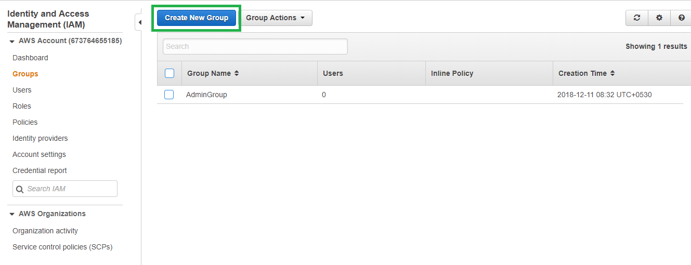

1. Provide group name and attach administrator access policy so that the new group will get administrative privileges.

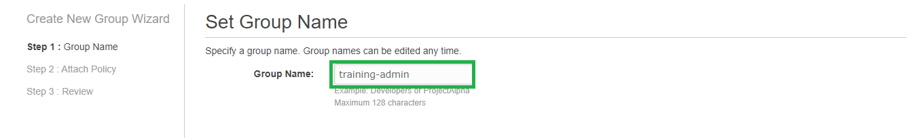

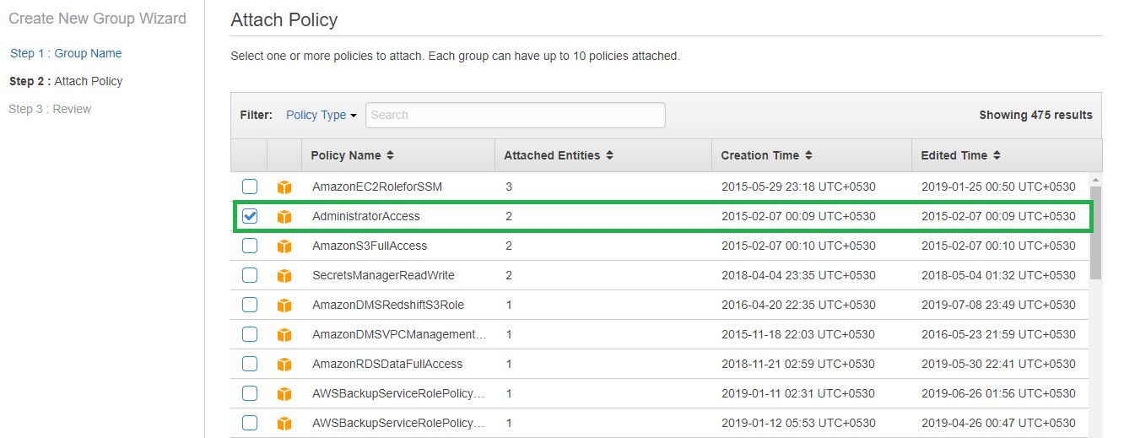

1. Review the information provided and click create to get the group created.

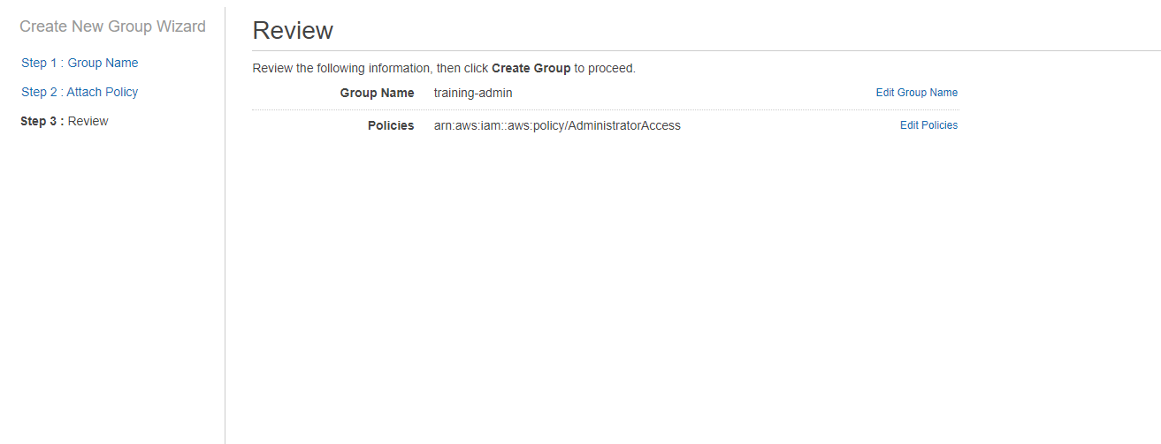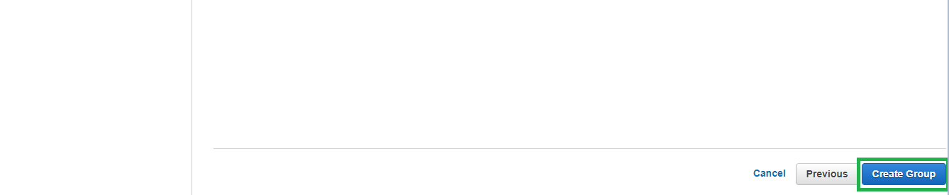

1. Verify the group and its permissions using the policy attached.

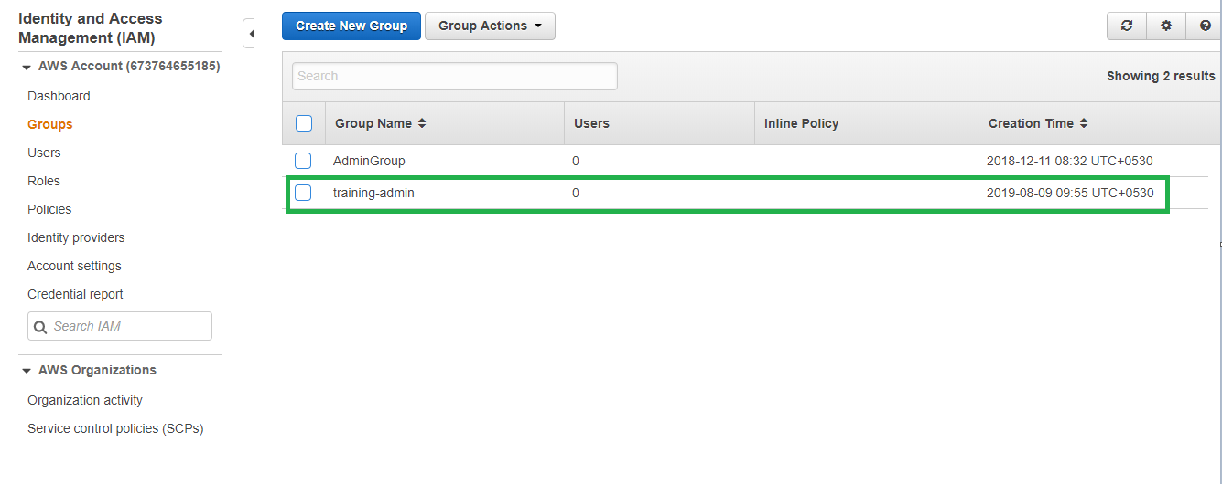

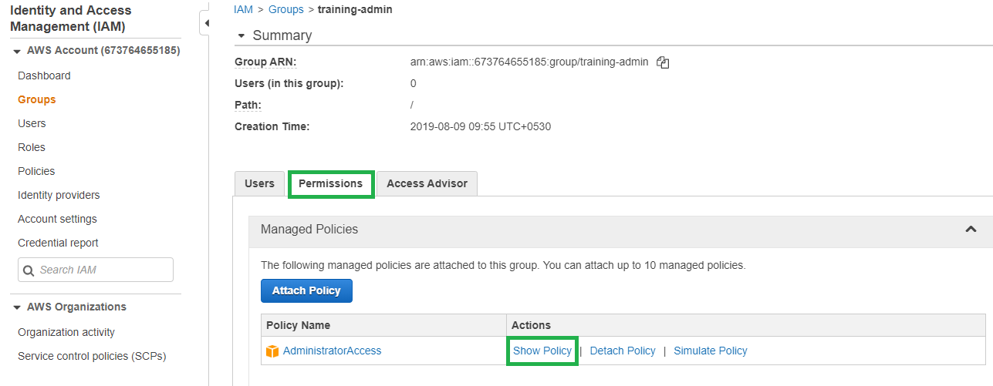

1. Policies are written in json language and below is the json code for the policy with administrative access.

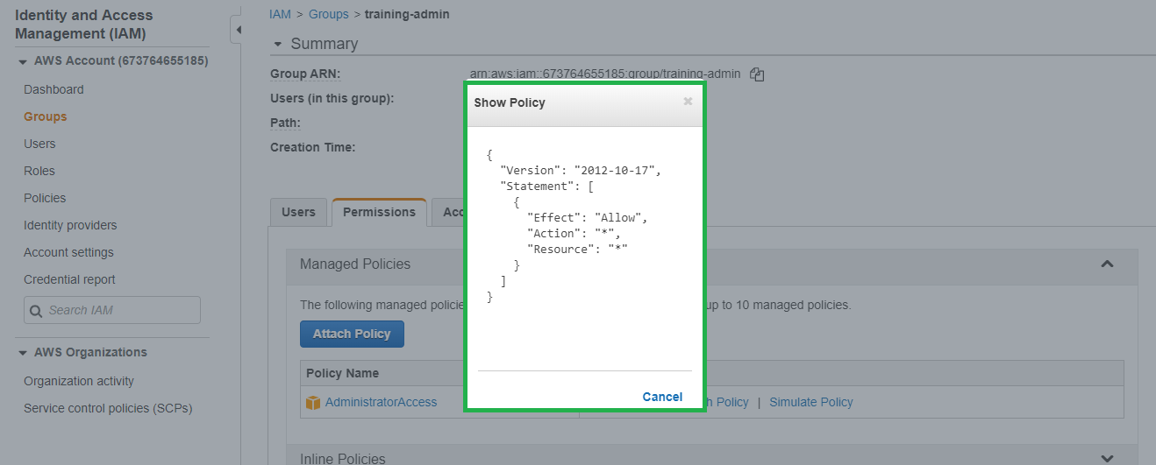

1. Create new user and assign the admin group.
2. IAM 🡪 Users 🡪 Add User.

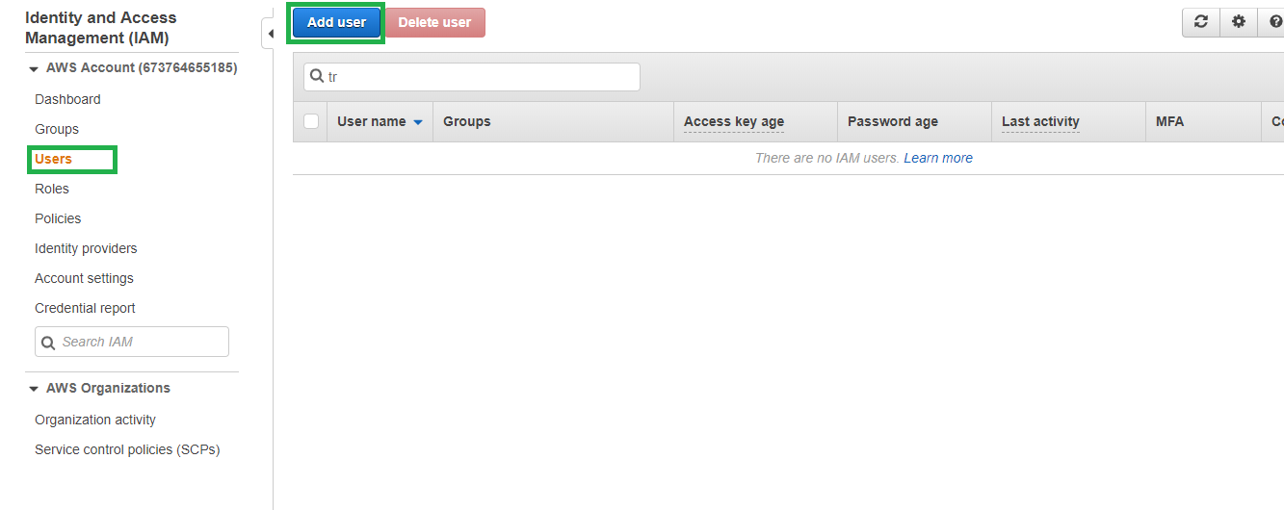

1. Provide the user information and select access type as both programmatic and console access. Provide complex password for the new user and click next.

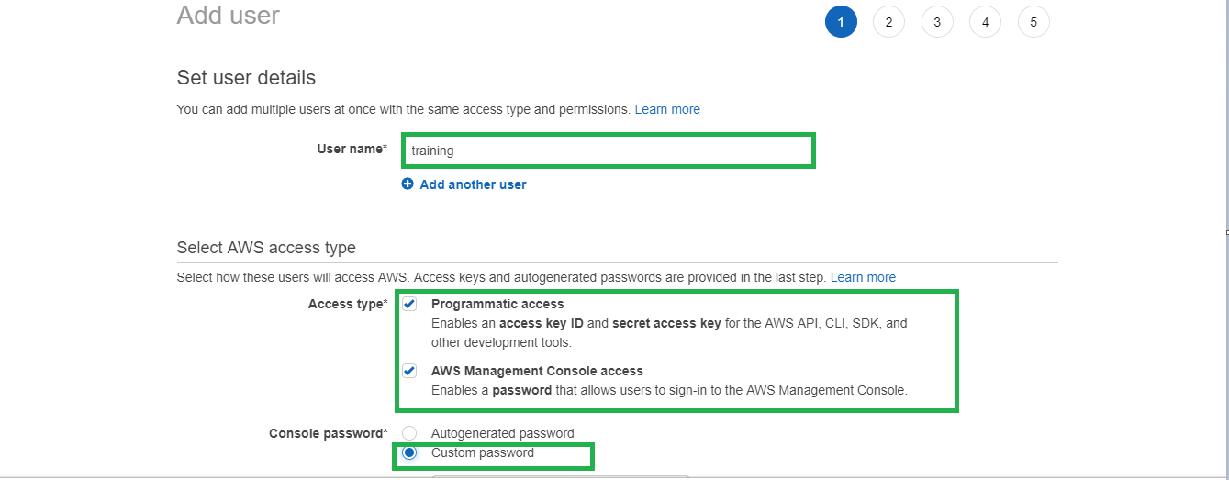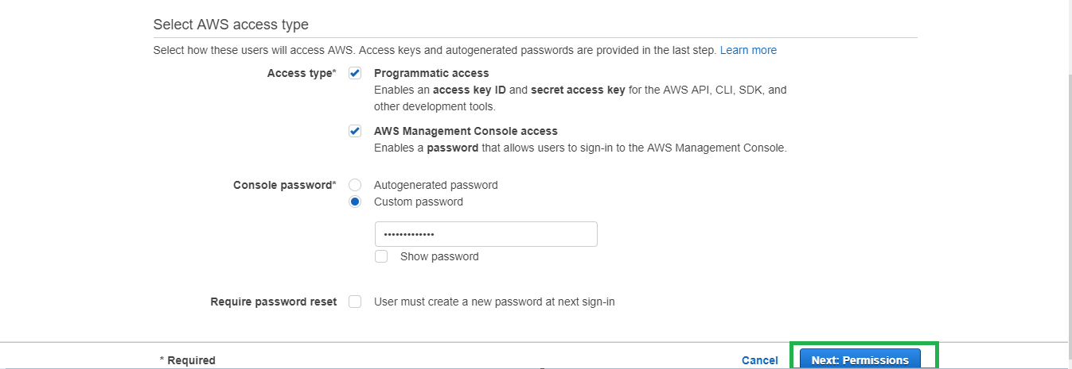

1. The new user ca be assigned permission through goup/existing user or directly attaching policies. Best practise is to provide permission through group.

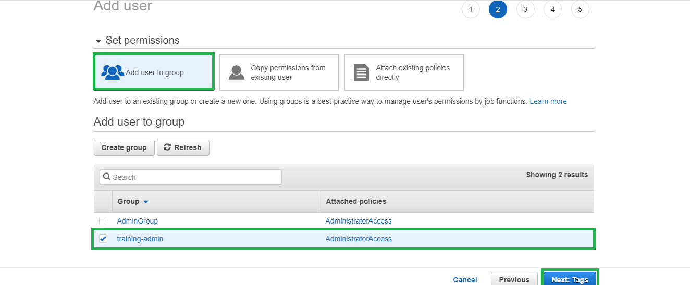

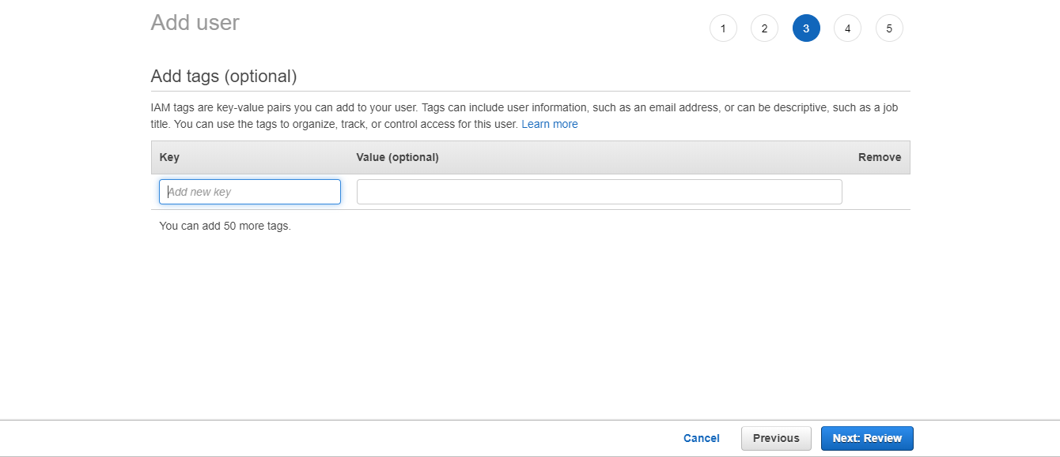

1. Review the information and click create user.

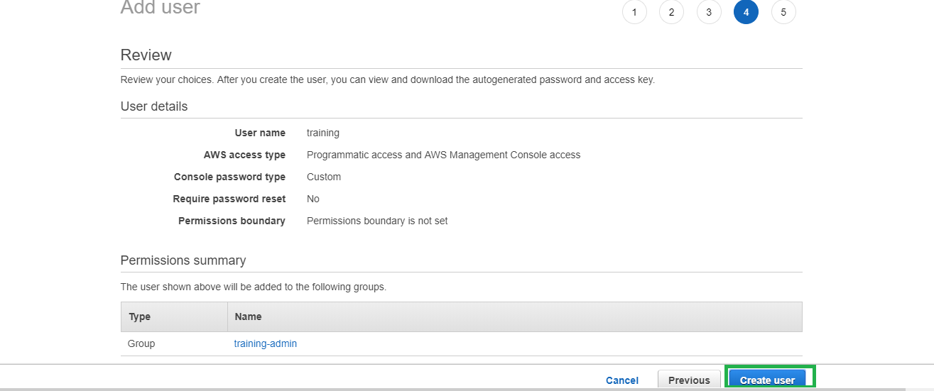

1. Download the credential file for the user.

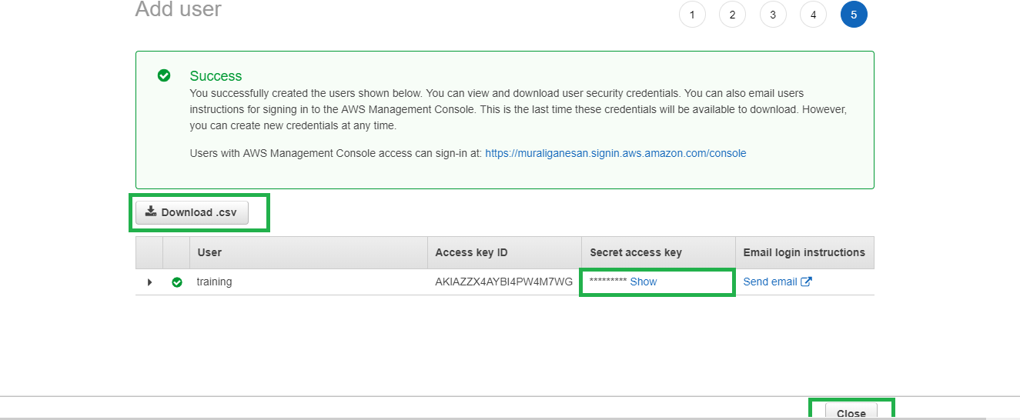

1. Verify the user is created. Logout current session and login with new user and verify the access.

